EC2 TASK
- Launch one EC2 using Amazon Linux 2 image and add a script in user data to install Apache.
STEP : 1
Opened AWS Consol and go to instance and launch instance
Name : amazon-apache
AMI : amazon machine image
Key pair : choose or create
Network : default
Subnet : chose anyway
Auto-assigned public IP : Enable
Security group : Allowed SSH : PORT NO : 22
Allow HTTP : Port (80)
STEP : 2
ADD BASH SCRIPT user data to install apache
In advance option there is one box write tbash script to install apache
#!/bin/bash
Sudo yum update -y
Sudo yum install httpd -y
Sudo systemctl start httpd
Sudo systemctl statu httpd
STEP : 3
Launch instance successful
Connect to terminal
Check apache is active are not by using sudo systemctl status httpd
STEP : 4
Instance running
Copy IP Address
Oper browser paste IP
Now we can see “APACHEIS SUCCESSFULLY RUNNING” In web page
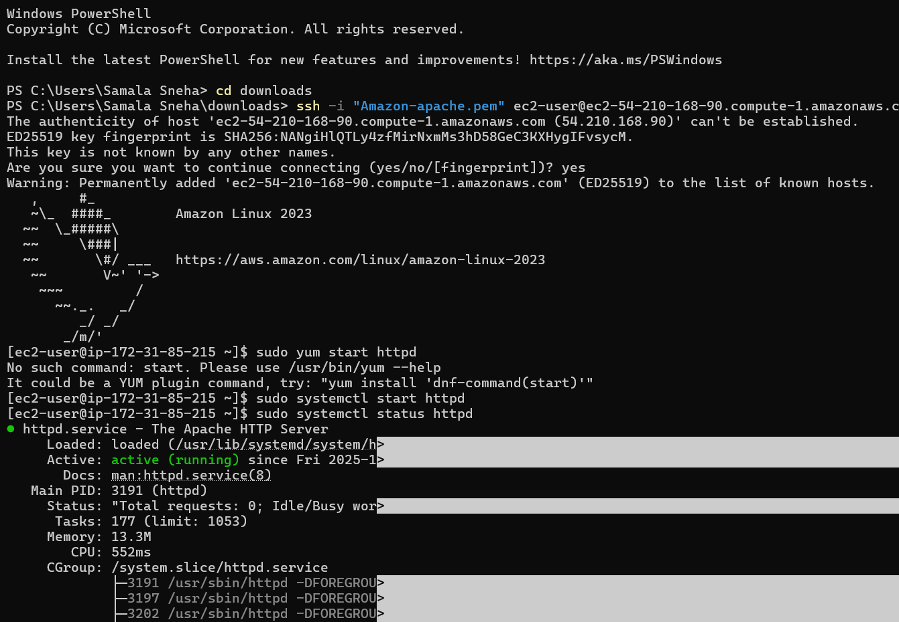
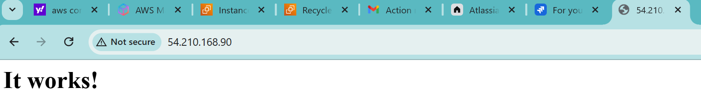
INSTALLED APACHE IS SUCCESSFULL
- Launch one EC2 using Ubuntu image and add a script in user data to install Nginx.
STEP : 1
Lanch EC2 instance
Select ubuntu under OS/AMI section
STEP: 2
ADD USER DATA SCRIPT
#!/bin/bash
Sudo apt update -y
Sudo apt install nginx -y
Sudo syatemctl start nginx
Sudo systemctl status nginx
STEP : 3
Connected the terminal / ec2 consol confirmed nginx status activated an d installed

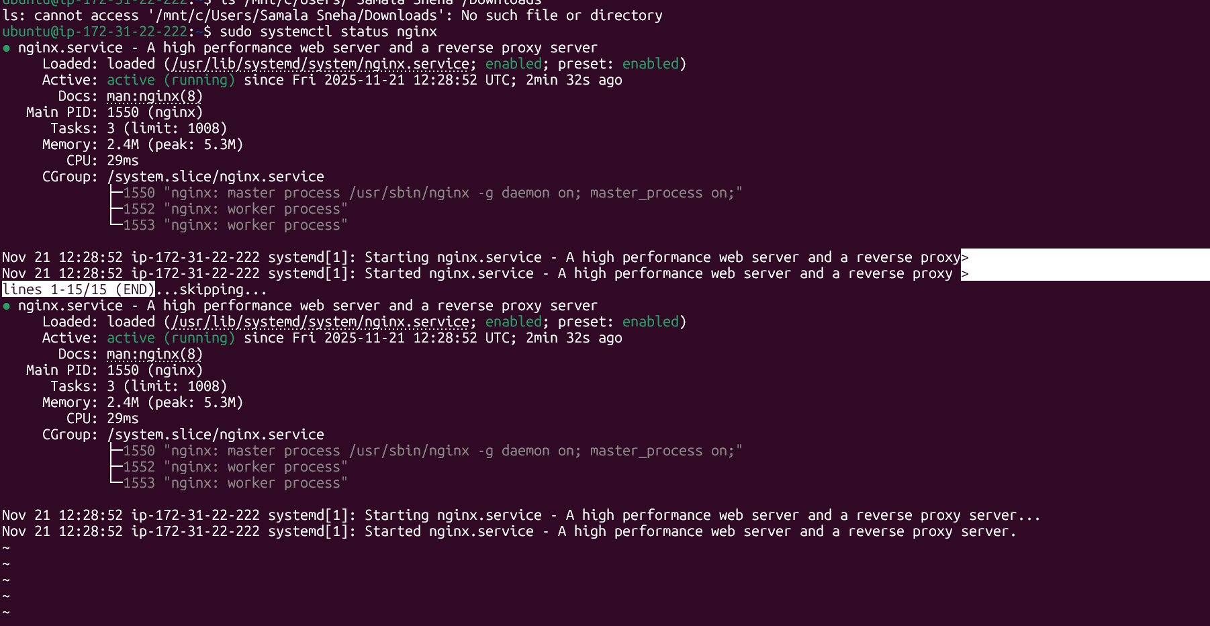
STEP-4
Go to instance copy IP
And browse with web page
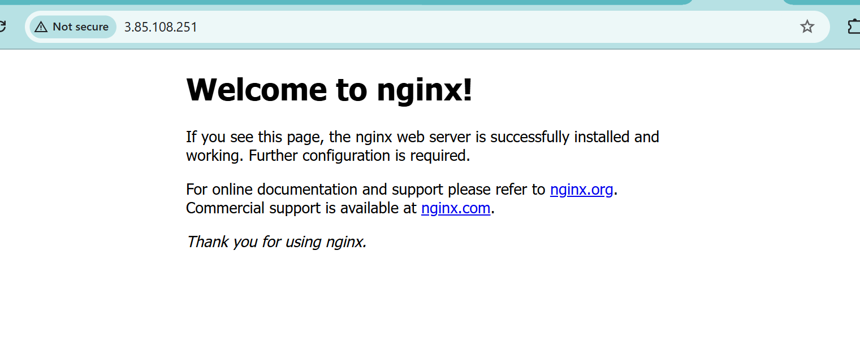
Successfully nginx is installed
- Launch one Windows server and install Tomcat on Windows.
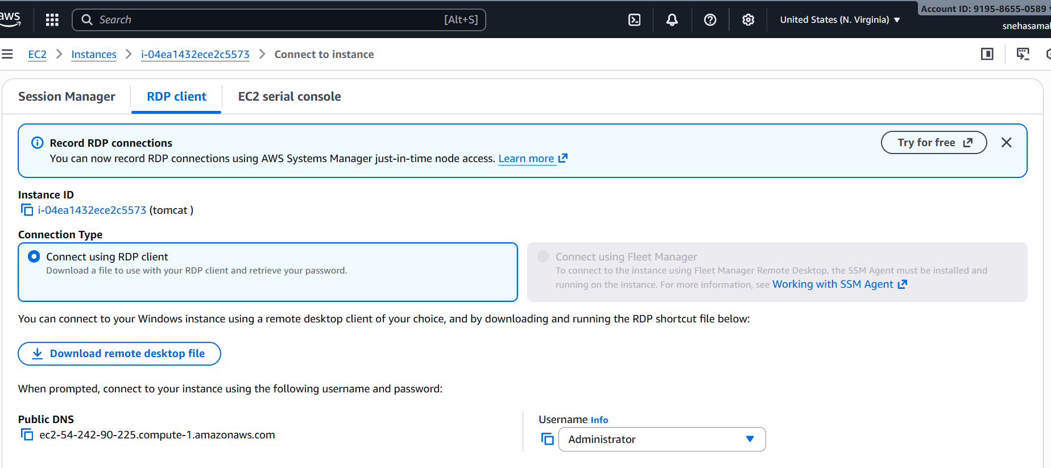
✅ Tomcat Installation & Setup on Windows Server — Summary
Below is the full step-by-step process you completed, including validation.

🔹 1. Install JDK (Java Development Kit)
Download JDK using CLI
curl.exe -L -o jdk.zip https://aka.ms/download-jdk/microsoft-jdk-25.0.1-windows-x64.zip
Extract JDK
Expand-Archive "C:\Users\Administrator\jdk.zip" -DestinationPath "C:\Java"
The folder created:
C:\Java\jdk-25.0.1+8
Set JAVA_HOME
setx JAVA_HOME "C:\Java\jdk-25.0.1+8"
Add JAVA to PATH
setx PATH "%PATH%;C:\Java\jdk-25.0.1+8\bin"
Validate Java Installation
java -version

🔹 2. Download & Install Apache Tomcat
Download Tomcat ZIP using CLI
curl.exe -L -o tomcat.zip https://dlcdn.apache.org/tomcat/tomcat-10/v10.1.49/bin/apache-tomcat-10.1.49.zip
Extract Tomcat
Expand-Archive tomcat.zip -DestinationPath "C:\Tomcat"
Final folder:
C:\Tomcat\apache-tomcat-10.1.49

🔹 3. Start Tomcat
Navigate to Tomcat bin directory:
cd C:\Tomcat\apache-tomcat-10.1.49\bin
Start Tomcat:
startup.bat
Output should show Tomcat started.

🔹 4. Validate Tomcat Service
Check if Tomcat is listening on port 8080:
netstat -ano | findstr 8080
Expected:
TCP 0.0.0.0:8080 LISTENING
Validate from browser (on server):
http://localhost:8080

🔹 5. Enable External Access (Firewall Fix)
Tomcat was running but blocked by Windows Firewall.
Allow port 8080:
netsh advfirewall firewall add rule name="Allow Tomcat 8080" dir=in action=allow protocol=TCP localport=8080

🔹 6. Access Tomcat Externally
From your local system:
http://<EC2-PUBLIC-IP>:8080
e.g.
http://54.242.90.225:8080

🎉 Final Result
✔ Java installed
✔ JAVA_HOME configured
✔ Tomcat installed
✔ Tomcat running on port 8080
✔ Windows Firewall rule added
✔ External access working successfully

If you want, I can also prepare:
✅ A full documentation PDF
✅ A step-by-step diagram
✅ A script to automate the entire installation
Just tell me!

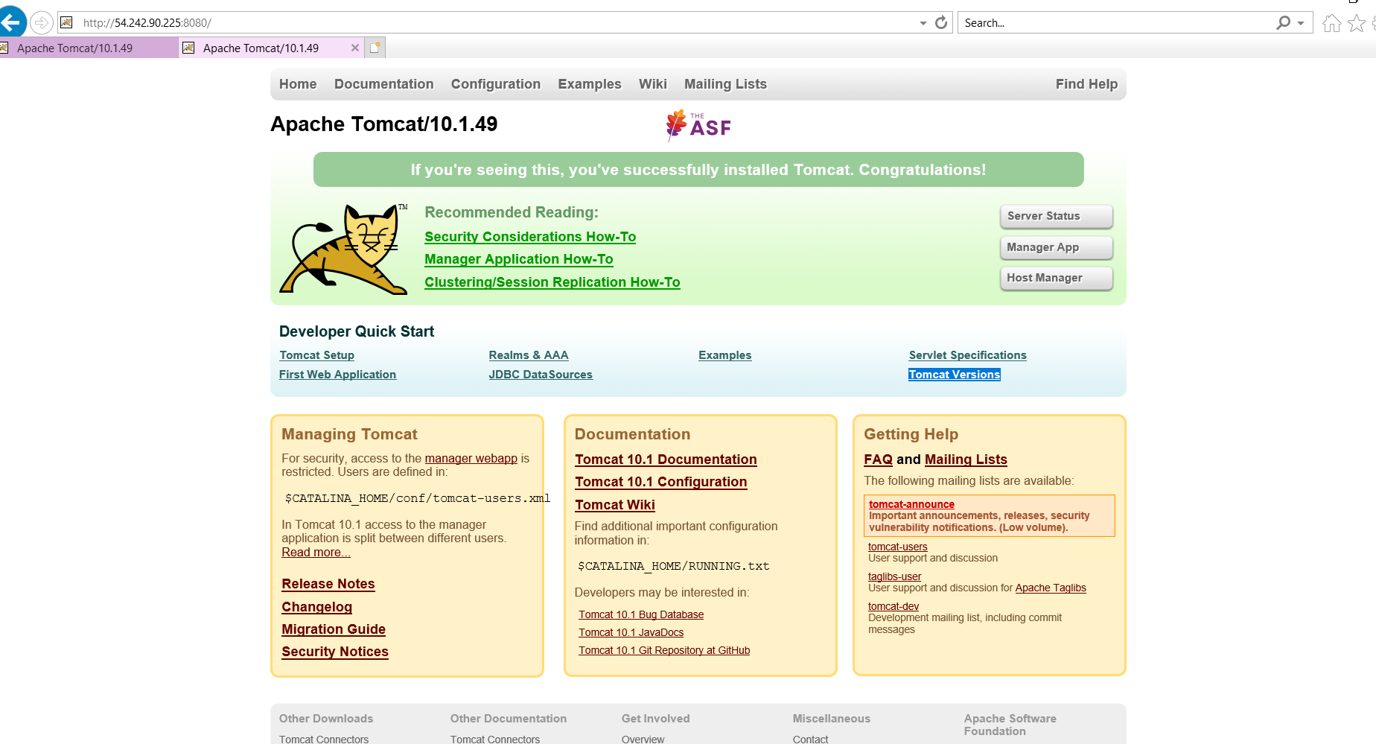

- Take a snapshot of the instance created in Task 1.
STEP-1
Create a Snapshot in (AMAZON LINUX)
Selecte the AMAXON LINUX INSTANCE
Launch EC2 instance
To storage tab
STEP-2
Open the root volume
Click the volume ID
VOLUME ID : vol-01d5b56e96d148e77
STEP -3
Go to action
Create snapshot : add name description
Create snapshot
STEP-4
Confirm in EC2 – snapshot
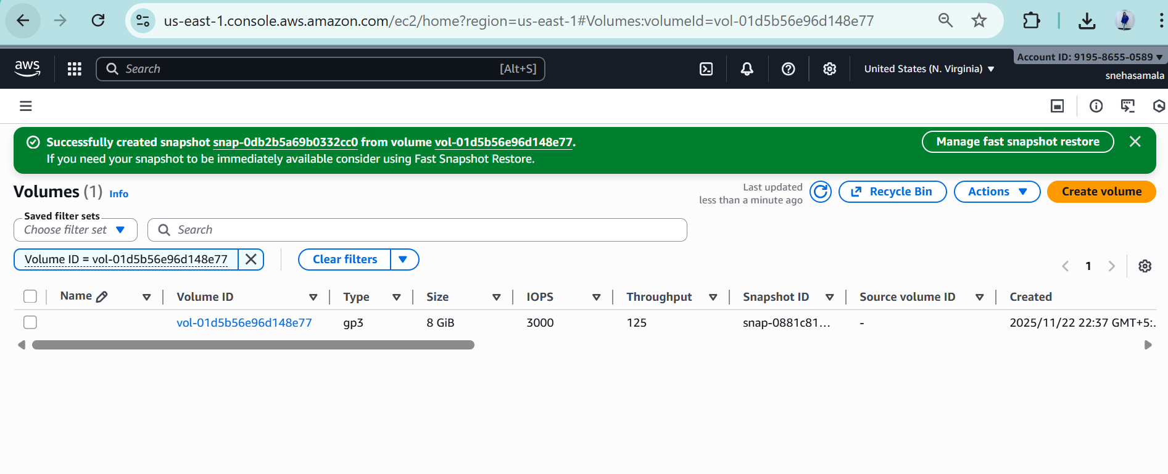
- Assign passwordless authentication for the EC2 created in Task 2

• Generate a new SSH key pair on your local machine.
Create a private key (kept secret on your laptop) and a matching public key (which you will copy to the server). The private key is used by your SSH client to prove your identity; the public key goes into the server’s authorized list.
• Locate the newly created public key file on your local machine.
Identify the exact path and name of the public key file so you can transfer the correct file to the server. The public key is safe to copy — it contains no secret.
• Transfer (copy) the public key from your local machine to the EC2 instance.
Move the public key file to a temporary location on the server so it can be placed under the new user’s SSH directory. This step requires authenticating to EC2 with the instance’s original key (the .pem file).
Create the new user account on the EC2 instance.
Add the system user (for example, techie) so there is a home directory and a place to put SSH configuration for that user. Creating the user is necessary before assigning SSH access.
Create an .ssh directory inside the new user’s home directory.
The .ssh directory is the standard location for authorized public keys and SSH-related files for that user. It must exist before adding the key.
Append the transferred public key to the new user’s authorized_keys file.
Place the contents of the public key file into the authorized_keys file so the SSH server recognizes and accepts connections made with the matching private key.
Set strict permissions on the .ssh directory and authorized_keys.
SSH enforces file-permission rules; the directory and file must be limited so they are not writable by others. Correct permissions prevent SSH from refusing the key for security reasons.
Ensure the .ssh directory and authorized_keys are owned by the new user.
The SSH server requires that the new user be the owner of their .ssh folder and authorized keys; otherwise public-key authentication will fail.
Confirm SSH server allows public-key authentication.
Check that the SSH daemon is configured to accept public-key logins. If public-key authentication is disabled, key-based login won’t work even if keys are correctly placed.
Restart or reload the SSH service if you changed its configuration.
If you edited SSH configuration, apply those changes by reloading the SSH server so it uses the updated settings.
From your local machine, use the private key to attempt an SSH login as the new user.
Test the setup by connecting to the EC2 instance as the new user while specifying the private key. The private key stays on your laptop — the server only needs the public half.

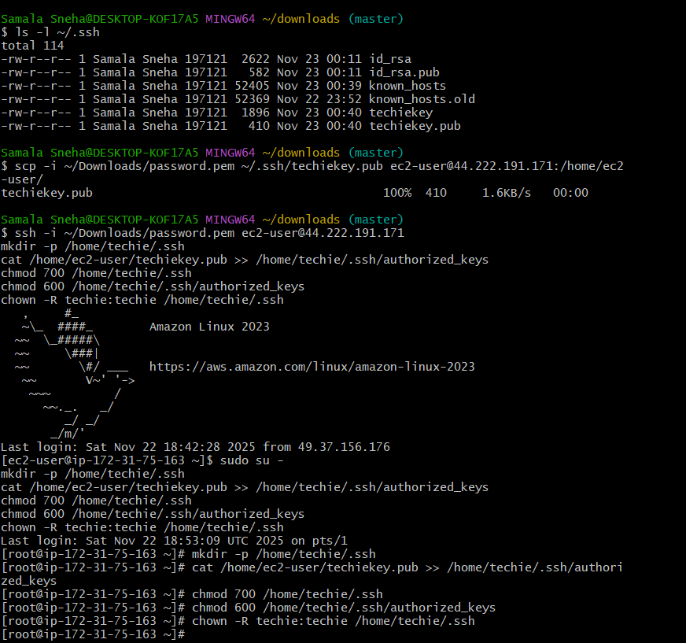

- Launch any EC2 using the spot purchasing option.
EC2 CONSOL – Lunch instance
Select AMI machine (OS)
Configuration – CPU,RAM
Select purchasing option-on demand or stop

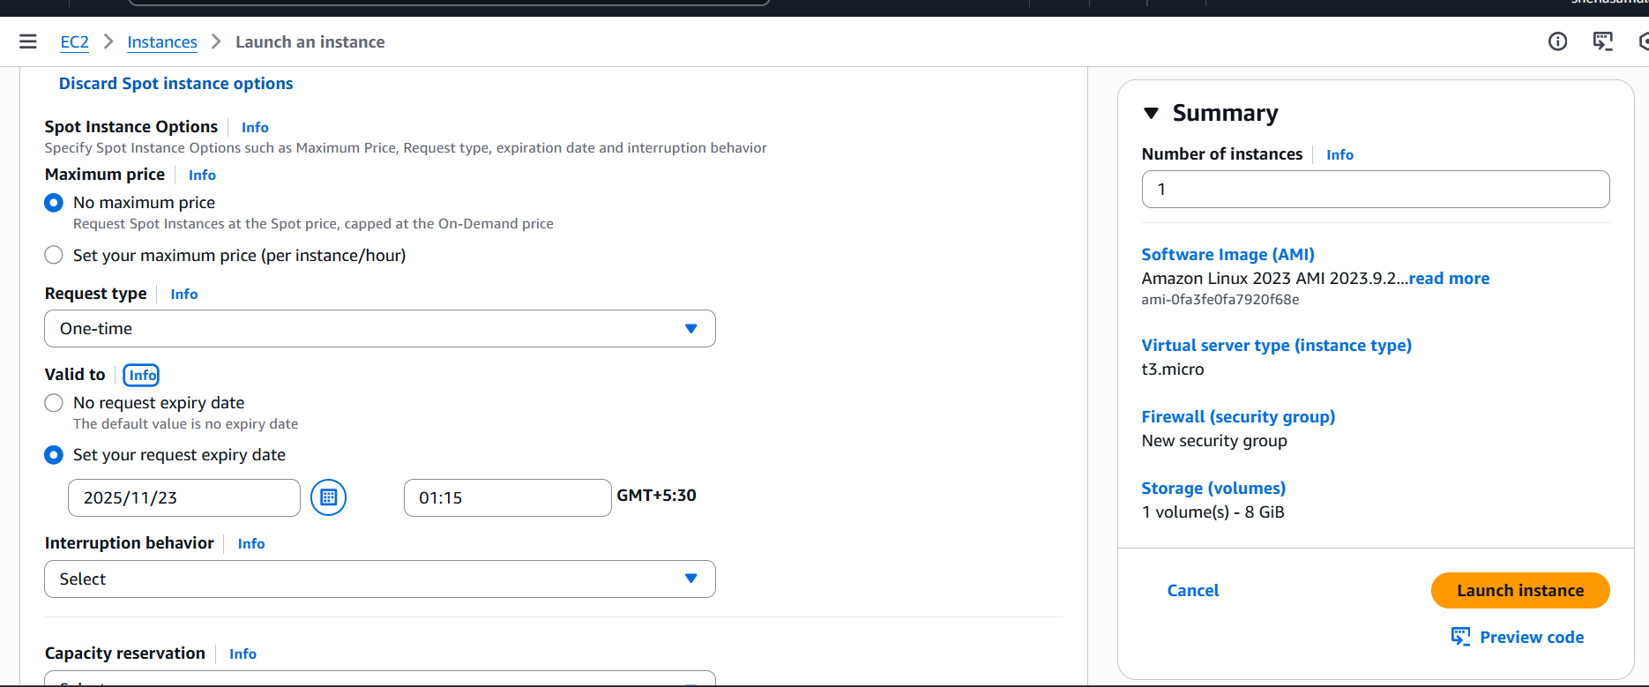
- Enable termination policy on the EC2 created in Task 2.
Launch EC2 instance
Go to actions and select instance setting and change termination policy to terminate
Then after enable and save

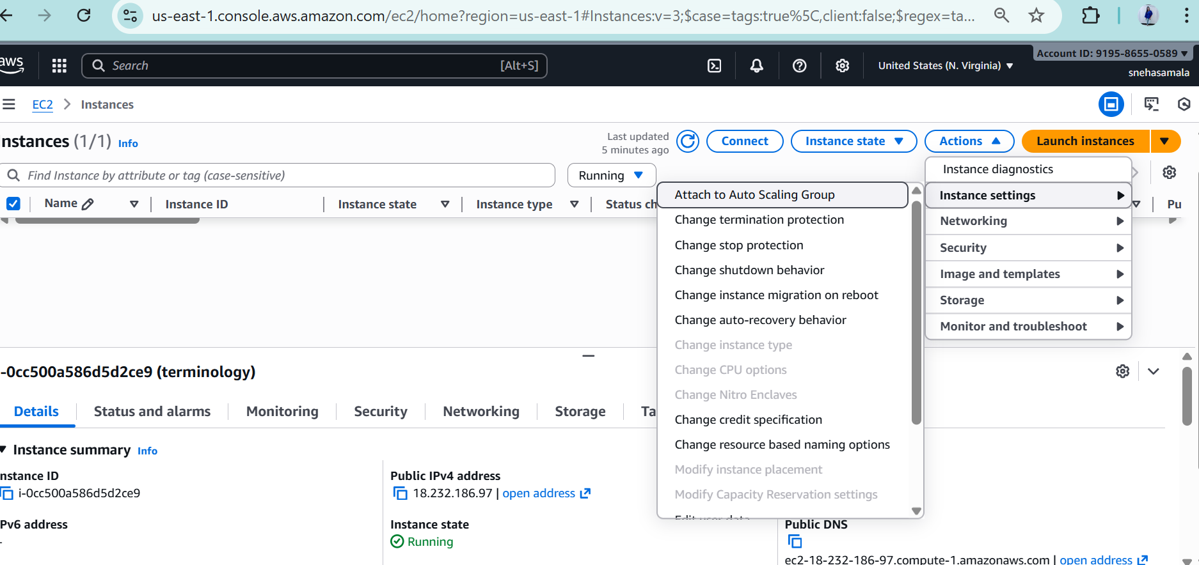
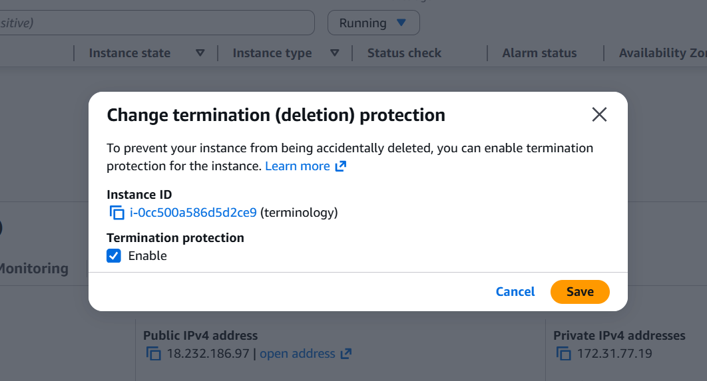

- Launch one EC2 using AWS CLI.
- Luanch the instance.
- Then connect to the instance with remote server.
- Then wget https://awscli.amazonaws.com/AWSCLIV2.msi paste the link.
- Then it will be download the aws cli.
- The go to the command of aws configure.
- Then it will be ask for key which is we will find for security credentials in aws account.
- Then create a acces key for that.
- Region and format is :
- Region is us-east-1
- Format is json
- Then use the command of
- Aws ec2 describe-instances
- Here the results are:

